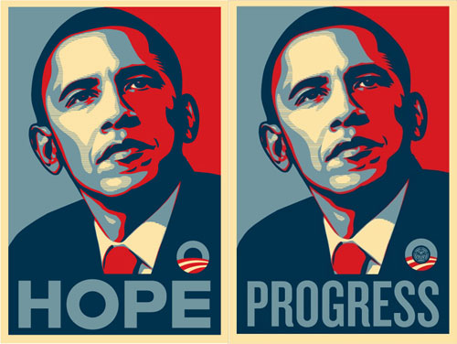
Shepard Fairey
Project 6

From its beginnings, printed art has been made in multiple copies for dissemination to a wide audience. Create an 8.5”×11” propaganda poster promoting an action/ideology of your choice. Use the appropriate principles and design elements you have learned so far: Balance, Unity, Rhythm and Repetition, Scale and Proportion and/or Illusion of Space to convey your message. In addition you must use a limited color palette – analogous, triadic, complementary or monochromatic--no more than three colors (in addition to black and white). Your project must be printed and mounted on black foam core with a 2” border. Supplement your poster with a 1 page persuasive essay/advertisement conveying your propagandist ideology!

Objectives
Explore the power of the design principles you have learned so far
Simplify visual information and color palette for graphic impact
Gain mastery over simple layout and scaling techniques
Use color as a method of conveying emotion
Use text and type as an integral element in your visual work.

Process
1. Begin by making a stream of consciousness list of ideas, feelings, and topics you think would make a powerful subject for your sign. Try to get beyond clichés by selecting five items from your list that interest you and brainstorm connections.

2. Supplement your list with research done at the library and online. Avoid the obvious, i.e. “War is Bad” and explore topics deeper to see how you can promote your ideas best. Begin taking notes and sketch out ideas for your supplementary essay.

3. Gather symbols and images that reference the ideas you have come up with – paste selections in your sketchbook or gather electronically and begin working in Photoshop. Brainstorm variations of these symbols.

4. Do a series of thumbnail sketches to develop the overall composition for your sign. Think about the design principles as means to generate interest. Remember unity (proximity, repetition, continuity)? How will the individual shapes form a “gestalt.” Think about the colors you will use and the emotional effect they will have. If you are using text (you do not have to), consider how it will interact with the rest of your composition.

6. When you have arrived at a strong marriage of idea and form, scale your shapes to fit within an 8×11.5 piece of paper or foam core.

7. You may use construction paper, you may hand draw, or use printed material for your design, but the final image must be well crafted and create a clean professional poster. (If needed, you may scan your design and reprint it to create a unified surface)

10. From your notes and other research, develop a 1 page persuasive essay/advertisement that promotes the ideologies present in your poster. This may take a variety of forms depending on the ideas you develop. Create a rough draft, edit, and revise before turning it in. The first rough draft will be due Thursday, April 11 by then end of class. Hand me a paper copy or email it to me: cmsobieralski@nmhu.edu

Evaluation will be based on strength of composition, appropriate use of color, clear and concise message, and excellence of craft.

Artists to look up
John Heartfield, Shepard Fairey, Banksy, Social Realist Propoganda, Chaz Maviyane-Davies, Guerilla Girls, Barbara Krueger, Thomas Nast, Red Scare images, etc.

